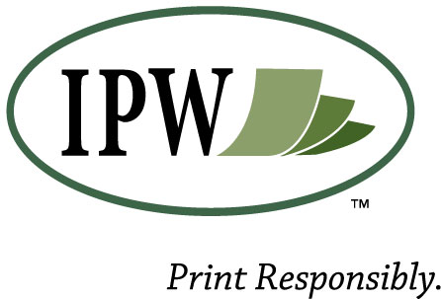
Toner & Fax Cartridges
Guarantee of Quality
IPW products represent the industry's most sophisticated technology and are passed on to you following strict inspection and performance testing. It is a continuing goal of Image Projections West, Inc. to provide the most exceptional print quality the industry offers.
Image Projections West, Inc. warrants each product to be free of defects in both material and workmanship for a period of one year from date of purchase. Image Projections West will, at its option, replace the product or refund the full purchase price of any product found to be defective.
Image Projections West, Inc. also warrants that, subject to conditions stated below and under normal use (including operation of printer equipment within specifications) our products will not cause damage, abnormal wear, or deterioration to any compatible laser printer. If a defect in our product causes a printer to fail, Image Projections West, Inc. will reimburse the client for the full amount for all service and repair of the printer. This warranty is dependent upon the customer providing IPW with the satisfactory evidence that the printer failure was due to a defect in product, including a written statement on the service company's letterhead, dated and signed by the company's field sales or service representative.
Image Projections West, Inc.'s liability hereunder shall be limited to replacement or reimbursement as provided above. This warranty is exclusive and in lieu of all other warranties, expressed or implied, including warranties of merchantability and fitness for a particular purpose.
14135 E 42nd Avenue, Suite 40
Denver Colorado 80239-4979
(303) 576-9477
www.ipwusa.com

